Jenkins intigrate with jfrog artifactory

Jfrog is universal binary repository

Step 1

Create a instance using t2 small.

In the sever download java to your system.

Using win Scp move the java to Linux (/tmp)

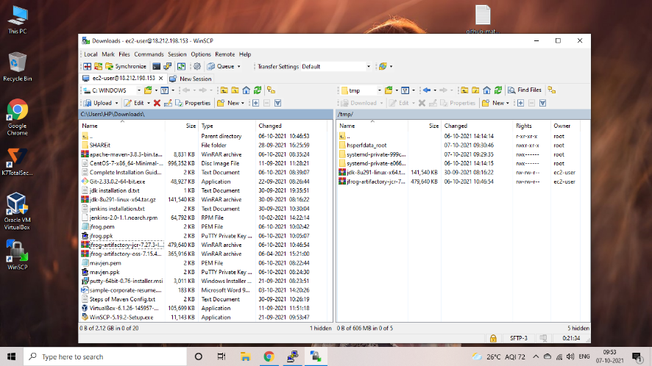

In your machine your will see the java in /tmp.

Then move that java to /opt folder using the command (mv).

Got cd /opt.

Extract the tar.gz file using the command (tar xvzf).

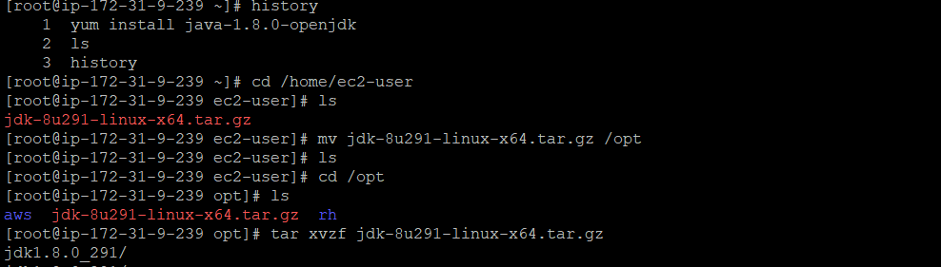

Step 3 install alternatives

Check the java version

Give path to java in (vi ~/.bash_profile)

After that download jfrog from the browser

Using Wget command Url

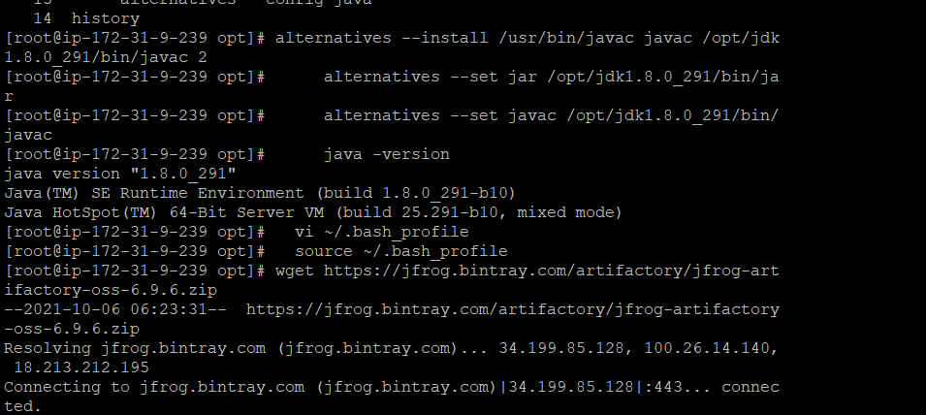

Step 4

Check jfrog downloaded or not

Then unzip the zip file using command (unzip)

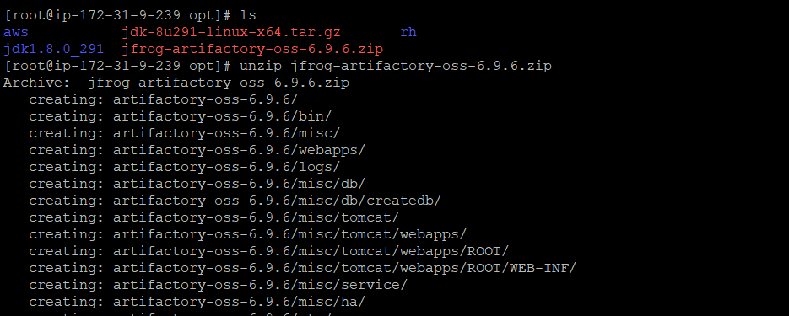

After unzipping the jfrog artifactory

Move into the artifactory and from artifactory move into bin

In bin

And start the jfrog artifactory using the command (./artifactory.sh start)

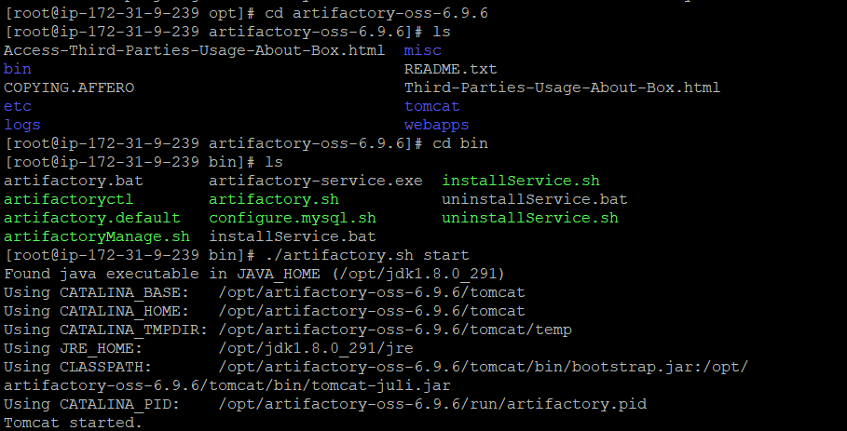

Take the ip address of instance

And check jfrog is working or not

http://ip:8081

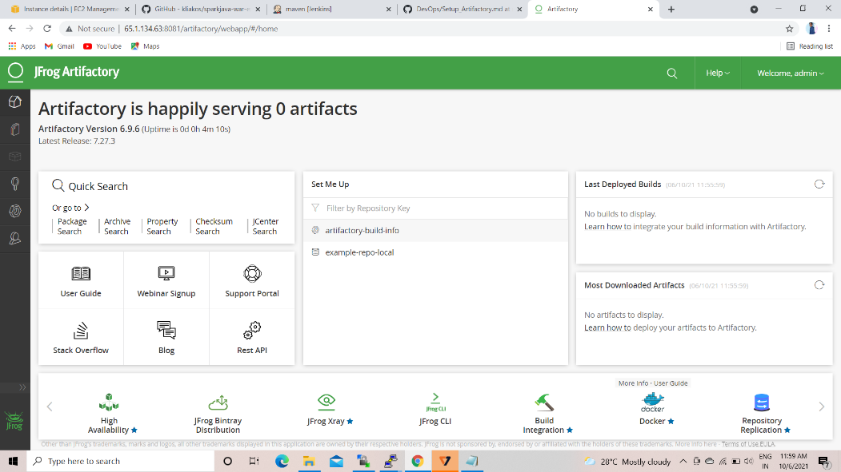

Open your Jenkins GUI

Go to manage jenkins

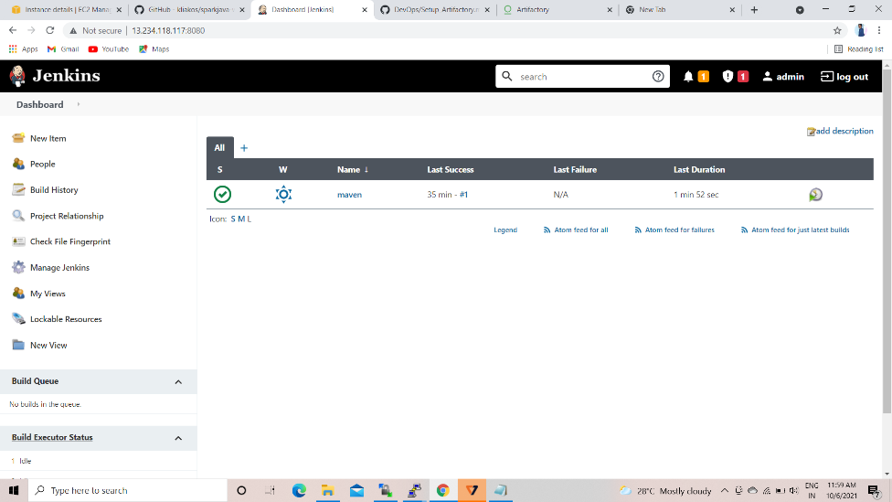

Go to manage plugins

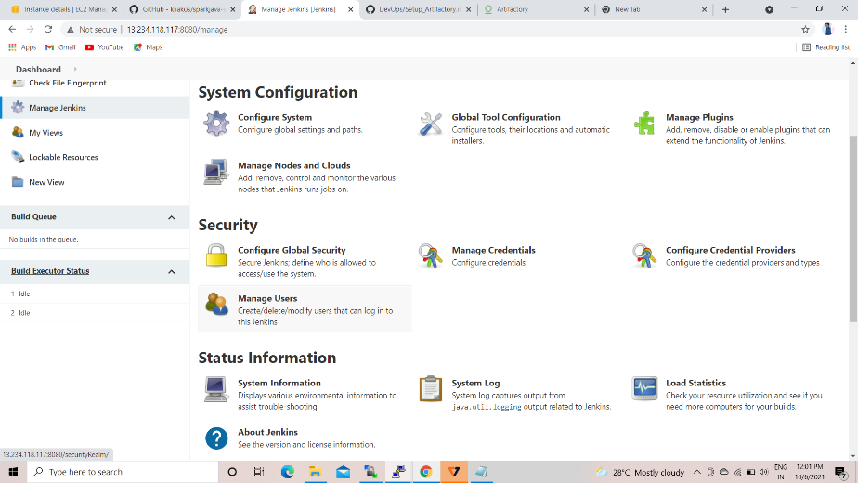

Go to manage jenkins download artifactory plugin

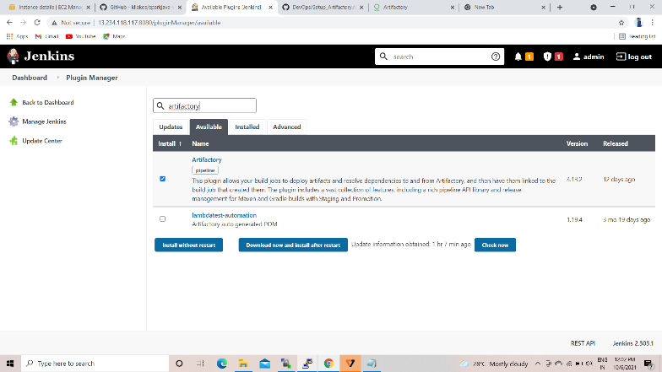

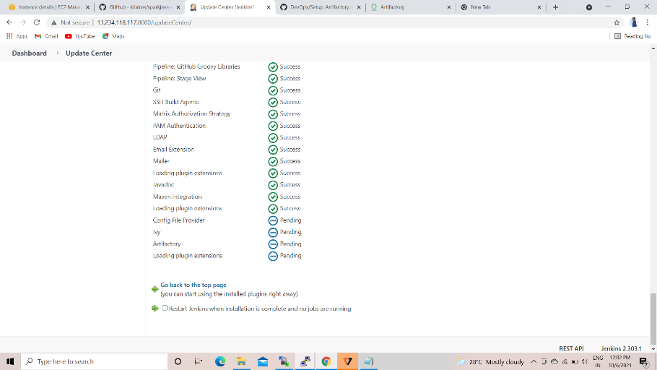

Go to manage plugins => configure system

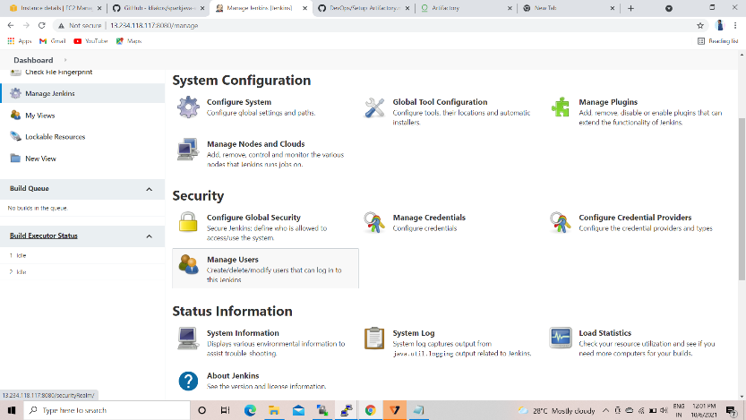

Here configure jfrog

Provide artifactory url , username and password

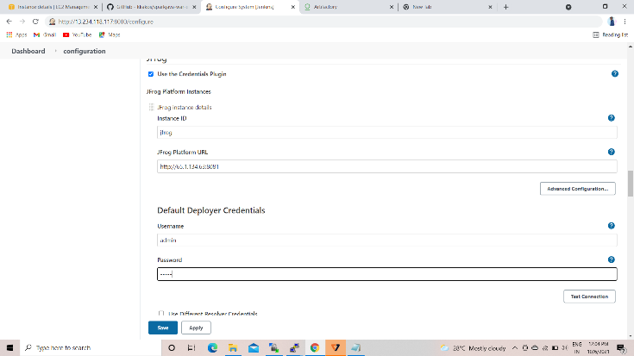

After configuring the jfrog with Jenkins open your job and go to configure

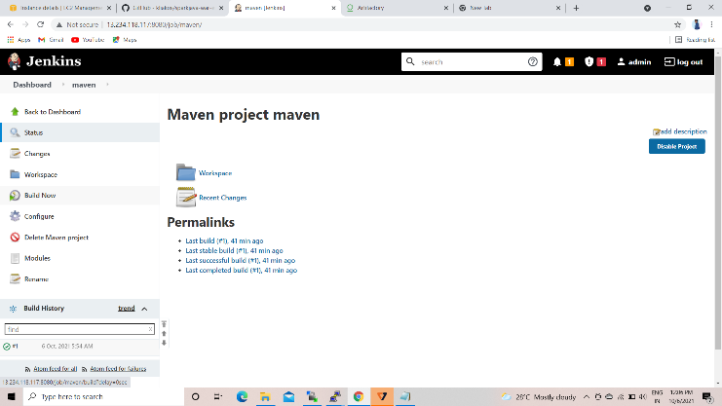

In your job

Go to configure postbuild option select deploy artifact to artifactory

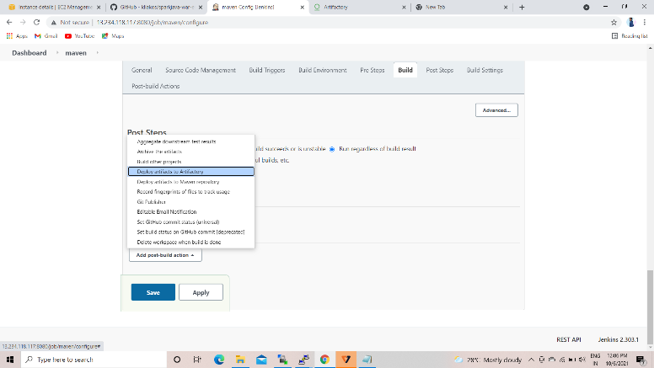

Provide artifactory ip and your repository here then save and build the job

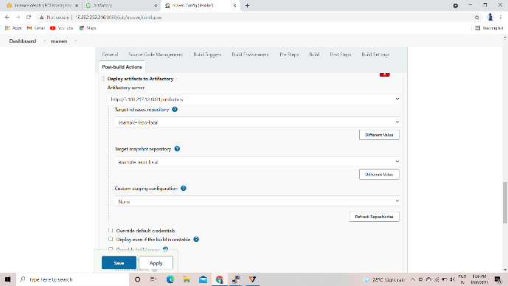

After building the job you will see like this

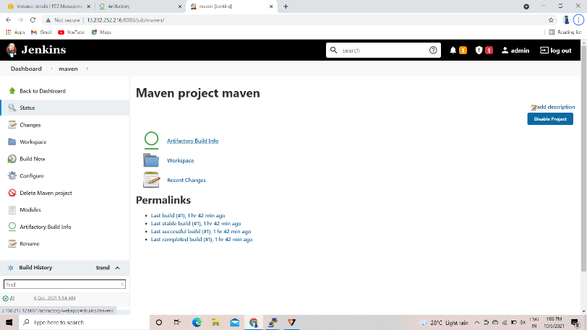

After building the job open your artifactory and check the job will build or not

After completion of build you will see the binary in the artifactory build section

